Full Stack Web Development Program

Using Node.JS Packages

DIY - 49

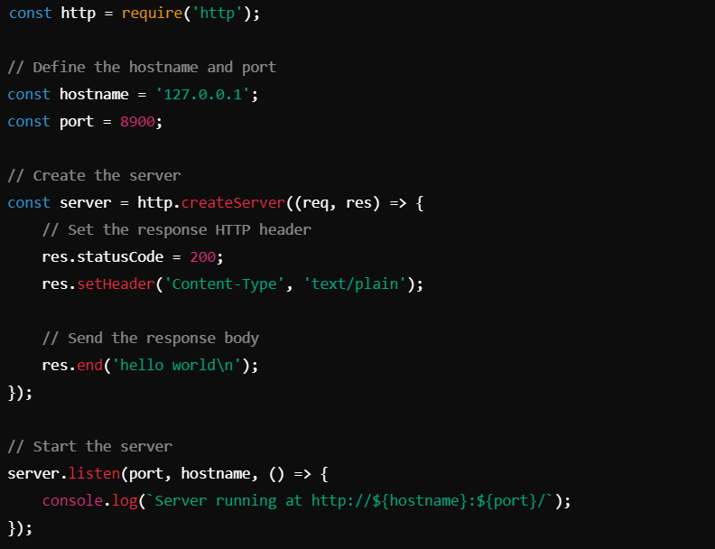

**Explanation:**

1. **const http = require('http');**: Imports the http module which provides utilities for creating HTTP servers and clients.
2. **const server = http.createServer((req, res) => { ... });**: Creates an HTTP server that listens for incoming requests. The callback function handles requests and sends responses.
   * **req**: Represents the request object.
   * **res**: Represents the response object.
3. **res.statusCode = 200;**: Sets the HTTP status code to 200, indicating a successful response.
4. **res.setHeader('Content-Type', 'text/plain');**: Sets the content type of the response to plain text.
5. **res.end('hello world\n');**: Ends the response and sends the string "hello world" to the client.
6. **server.listen(port, hostname, () => { ... });**: Starts the server and listens for incoming requests on the specified hostname and port. The callback function logs a message indicating that the server is running.

**Question 2: Create a server using the http package and define three routes: home, filter, and details. Print different text for each route. Print “page not found” if a route other than home, filter, and details is given.**

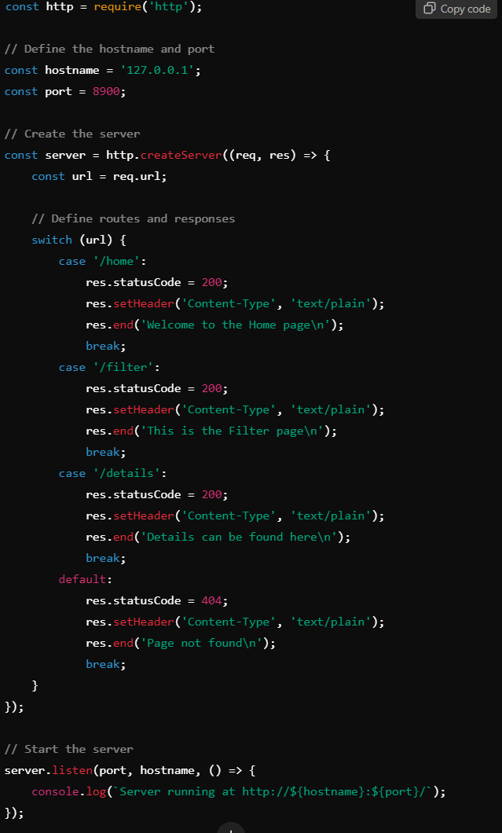

**Explanation:**

1. **const http = require('http');: Imports the http module.**
2. **const server = http.createServer((req, res) => { ... });: Creates an HTTP server.**
   * **req.url: Retrieves the URL of the incoming request to determine the route.**
   * **switch (url): A switch statement is used to handle different routes based on the URL.**
3. **case '/home':: Responds with "Welcome to the Home page" when the URL is /home.**
4. **case '/filter':: Responds with "This is the Filter page" when the URL is /filter.**
5. **case '/details':: Responds with "Details can be found here" when the URL is /details.**
6. **default:: Responds with "Page not found" for any other routes.**
7. **server.listen(port, hostname, () => { ... });: Starts the server and listens for requests on the specified hostname and port.**

**Running the Script**

1. **Save the code in a file named server.js.**
2. **Run it using Node.js from the command line:**



**Open a web browser or use a tool like curl to access:**

* **http://localhost:8900/home for "Welcome to the Home page"**
* **http://localhost:8900/filter for "This is the Filter page"**
* **http://localhost:8900/details for "Details can be found here"**
* **Any other route will return "Page not found".**